AI ASSITANT CODING
ASSIGNMENT-19
M.SHIVAMANI
2303A52344
BATCH-38

Assignment 19
Task 1 – Python to C++ Conversion Task:
Translate a simple Python class into C++ using AI assistance. Instructions:
- Prompt AI to convert a Python class representing a Student with attributes and methods into equivalent C++ code
- Ensure proper handling of:
- Constructors
- Data types
- Access specifiers
- Compile and run both versions to verify output consistency Expected Output:
An equivalent working C++ class translated from Python.

Python code:

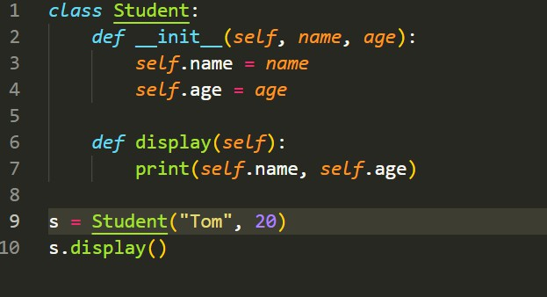

Prompt used:
Convert the following Python class into equivalent C++ code. Python Code:
class Student:
def init (self, name, age): self.name = name
self.age = age def display(self):
print(self.name, self.age) Requirements:
- Use proper C++ syntax
- Include constructor
- Use correct data types
- Use public access specifier
- Include main() function
Also ensure the output is same as Python.

Output:
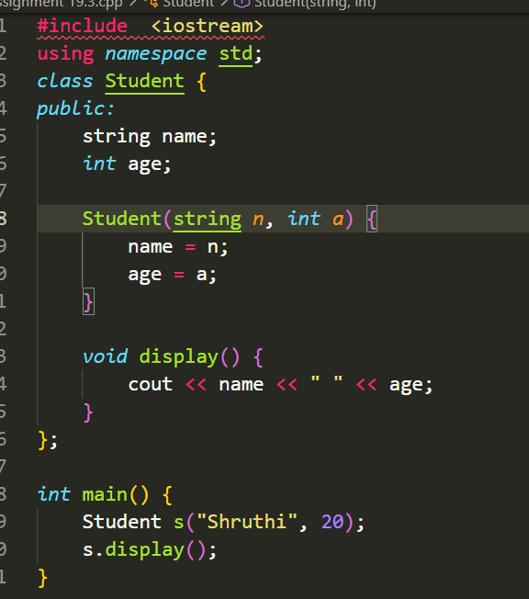

Task 2 – Java to Python Function Conversion Task:
Convert a Java method that checks whether a number is prime into Python.

Instructions:
- Ask AI to translate a Java isPrime() method into Python
- Test the function with multiple inputs
- Ensure the Python version follows Pythonic syntax and logic Expected Output:
A correct Python function equivalent to the original Java prime-checking method.
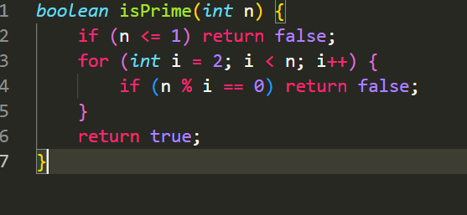
Prompt used:
Convert the following Java method into Python. Java Code:
boolean isPrime(int n) { if (n <= 1) return false;
for (int i = 2; i < n; i++) {
if (n % i == 0) return false;
}
return true;
}
Requirements:
- Follow Python syntax

- Use indentation properly
- Return True/False correctly
- Add a sample test case Output:
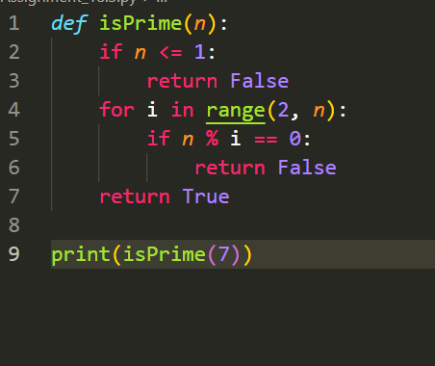
Task 3 – Pseudocode to Python Implementation Task:
Translate a given pseudocode algorithm into Python using AI. Instructions:
- Provide AI with pseudocode for sorting numbers (e.g., bubble sort or selection sort)
- Ask AI to convert it into executable Python code
- Validate correctness using sample input lists Expected Output:

A working Python program that correctly implements the pseudocode Convert the following pseudocode into Python code.
Pseudocode:
- Start
- Take a list of numbers
- Compare adjacent elements
- Swap if needed
- Repeat until sorted
- Print sorted list Requirements:
  - Use simple Python loops
  - Keep code easy to understand
  - Print final sorted output
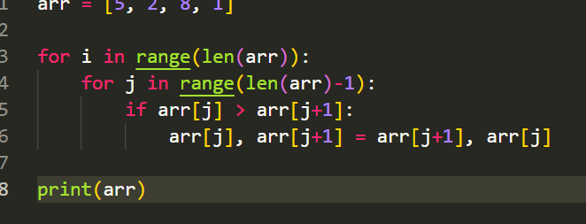
Output:
Task 4 – SQL to Pandas Query Task:
Translate a SQL query into a Pandas DataFrame operation in Python.

Instructions:
- Provide AI with a SQL query (e.g., SELECT name, salary FROM employees WHERE salary > 50000).
- Ask AI to generate equivalent Pandas code.
- Test the generated code on a sample DataFrame. Expected Output:
- Equivalent Pandas query that retrieves the correct subset of data. Prompt used:
Convert the following SQL query into Pandas Python code. SQL Query:
SELECT name, salary FROM employees WHERE salary > 50000; Requirements:
  - Create a sample DataFrame
  - Use Pandas filtering
  - Display the result
  - Keep code simple
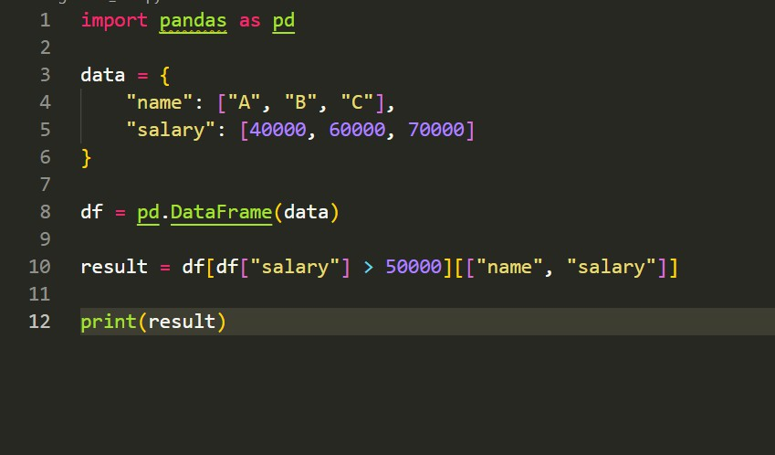

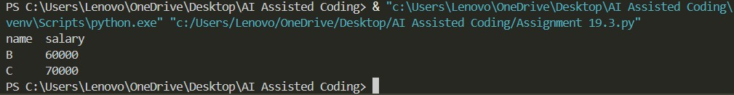

Task 5 – Real-Time Application: Algorithm Translation Across Languages
Scenario:
A company maintains algorithms written in different programming languages.
Examples:
- Converting a Python searching algorithm into C
- Translating a Java sorting program into JavaScript Instructions:
- Use AI to translate a selected algorithm between two programming languages
- Execute and test both versions
- Document translation challenges such as:
- Syntax differences
- Library support
- Memory management Expected Output:
Equivalent, tested code implementations in two different programming languages.
Prompt used:
Convert the following Python code into C language.

Python Code:

arr = [1,2,3,4,5]
key = 3
for i in arr: if i == key:
print("Found") Requirements:
  - Use C syntax
  - Use array properly
  - Include main function
  - Use printf for output
